3.48:

a)
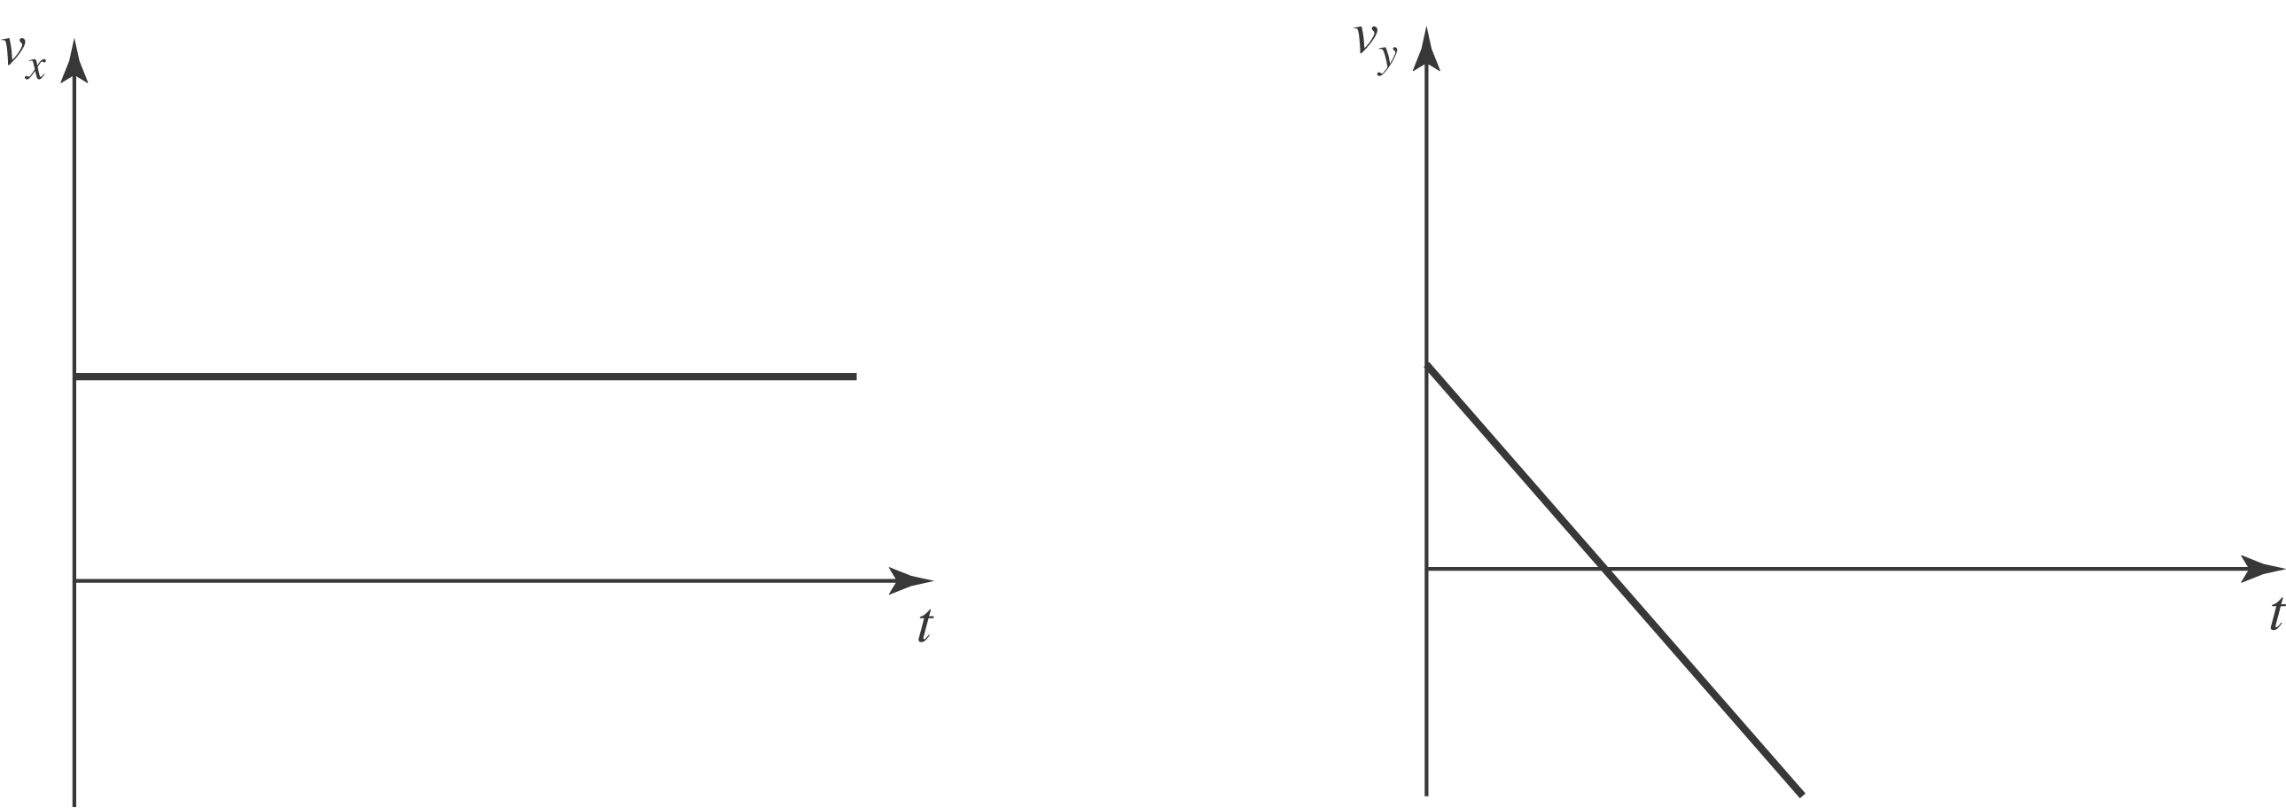

The equations of motions are:
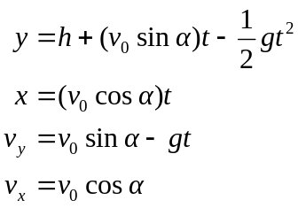
Note that the angle of 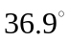 results in 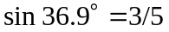 and 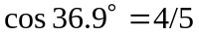.
b) At the top of the trajectory, 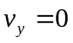. Solve this for t and use in the equation for y to find the maximum height: 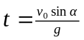. Then, 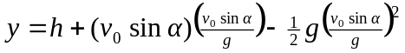, which reduces to 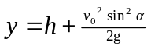. Using 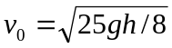, and 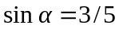, this becomes 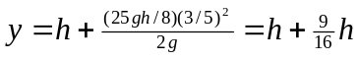, or 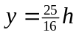. Note: This answer assumes that 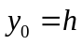. Taking 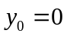 will give a result of 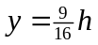 (above the roof).
c) The total time of flight can be found from the y equation by setting 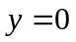, assuming , solving the quadratic for t and inserting the total flight time in the x equation to find the range. The quadratic is 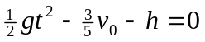. Using the quadratic formula gives 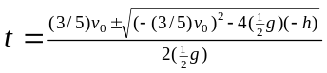. Substituting gives 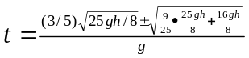. Collecting terms gives t: 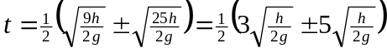. Only the positive root is meaningful and so 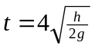. Then, using 

